Chapter 7, Problem 24.

Express the following signals in terms of singularity functions.

(a) 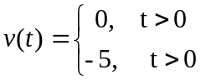

(b) 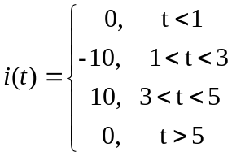

(c) 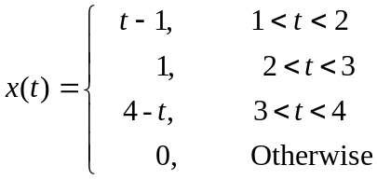

(d) 